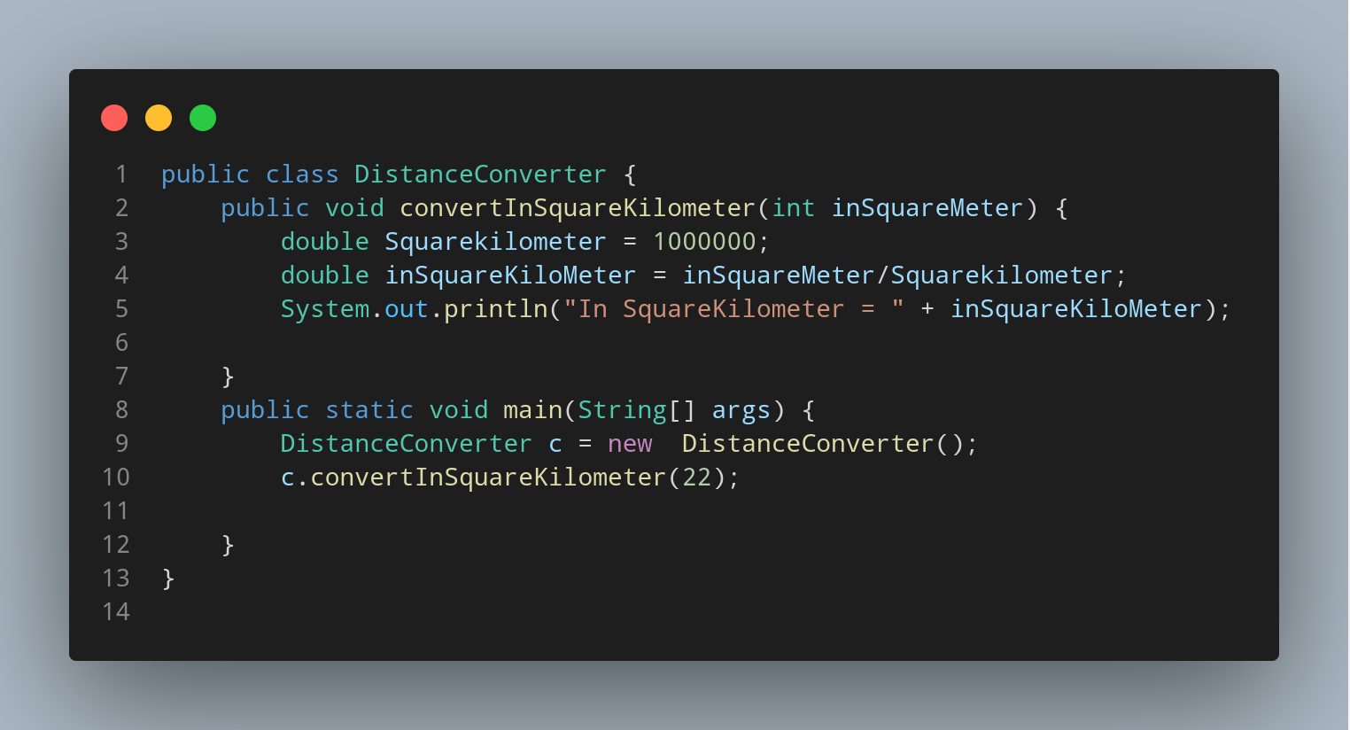

#Doc

We created our java file naming DistanceConverter so , we create a class having same name. Inside our class we created a method named convertInSquareKilometer having int inSquareMeter as parameter. Then we created a variable to store the number of square meter in one square kilometer. Lets create a variable to store our Conversion calculated value named as inSquarekiloMeter with leteral inSquareMeter/Squarekilometer.

Then we print our variable with suitable strings.

Now its time to create our main function.
Within main function first we instantiate our DistanceConverter class data type as variable c. Then we call our method giving the value of function parameter during calling method.

